**Ferry Road Health Centre**

**Autumn 2023**



**SURGERY NEWS**



Engage Consult is an online consultation service. You can use this messaging service to ask for help about a non-emergency medical problem or for general advice from the Doctor or other members of our practice team.

By signing up to use this service, you can get advice from us without the need to travel to the surgery or ring on the phone. Engage Consult can be used from any mobile phone, tablet or computer. You will need to have an email address to sign up.

Online consultations do not replace being able to see doctor, but give another option when a trip to the surgery is not necessary. The practice will reply with an answer to your question and tell you what you should do next. If you send your question within the online service times, you will usually get a reply on the same day.

For more information visit our website – ferryroadhealthcentre.net

Ferry Road/Rural Rother PCN

Working with other surgeries in the area we are able to provide a number of services within our PCN, including:

First Contact Physiotherapists

Cancer Care Co-ordinator

Tackling Health Inequalities Co-Ordinator

Care Navigators

Clinical Pharmacists

For more information visit the Rural Rother website – ruralrotherpcn.nhs.uk

*COURIER COLLECTIONS.*  We now have two collections a day, enabling us to provide phlebotomy services in the morning and afternoon, offering patients more flexibility when booking their appointments.

**STAFF NEWS**

We welcome Sue Minords and Julie Arthur to our Reception Team, along with Yvonne Macleod in Dispensary. We also have an Advanced Clinical Practitioner and an Independent Nurse Prescriber providing clinical support for the surgery.

They have undertaken additional medicaleducation in order to provide advanced nursing care and toprescribe medication. They can provide treatment and advice for many problems for which you may have seen a doctor for in thepast.

**WORD FROM THE PPG**

“Healthy Habits on a Budget”

We are pleased to announce that, in association with the Rye Medical Patient Participation Group, Alice Yeates – Diabetes and Energy Nutrition - will be giving a patient information talk on how healthier habits can help you feel better in yourself, and give you more energy for life.

The talk will provide practical ideas to transform your lifestyle, prevent disease and optimise your wellbeing without straining your wallet.

Do come along to the Hub on the Hill on Monday 16th October 6-8 p.m.

____________________________________________

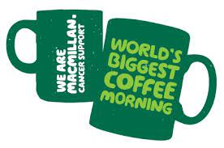

Once again this year we will be taking part in the Macmillan World’s Biggest Coffee Morning on Friday 29th September. Please come along and support this event between 10-00 and 12-00. ________________________________________

The PPG gifted the surgery with a Cheals’s Weeping Cherry tree in memory of H.M. Queen Elizabeth II

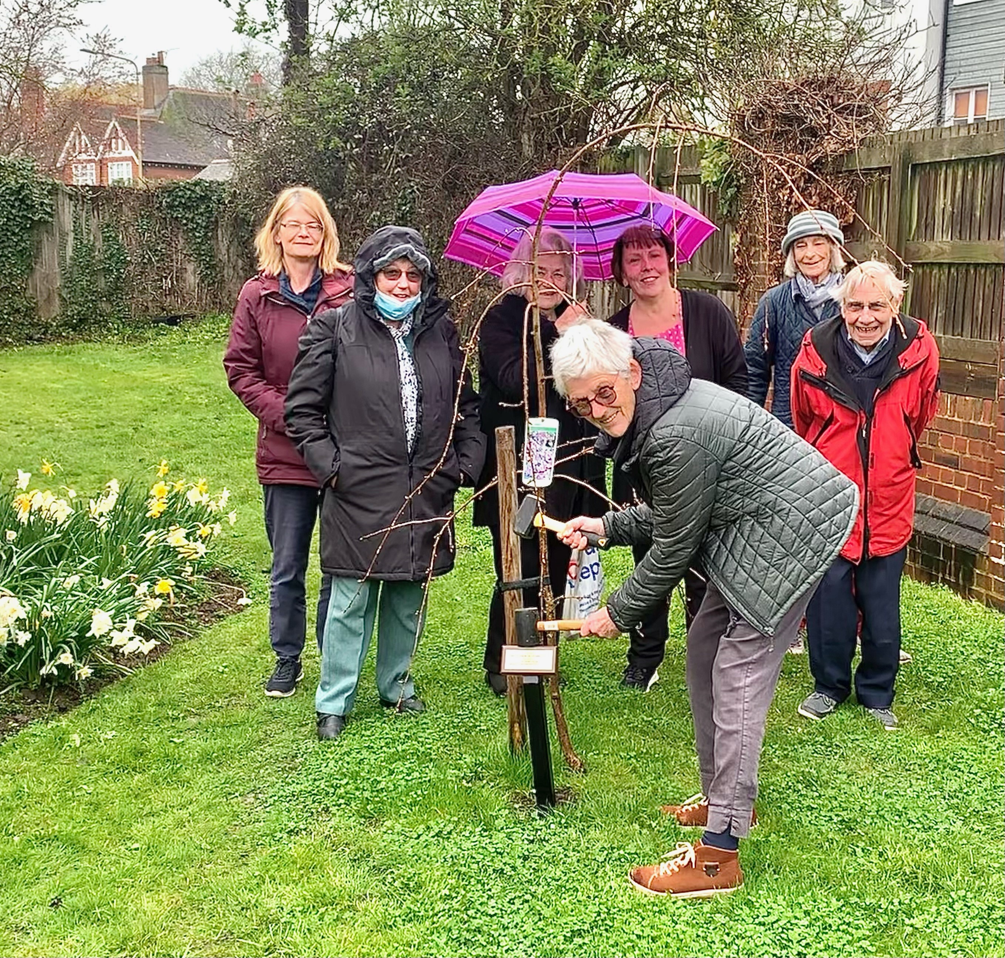

******VACCINATIONS

Seasonal Flu. This year patients will be offered a new way to book their flu vaccine. When we text you to say we are booking this year’s clinics you will be able to follow a simple link to ‘Self book’ a slot in one of our clinics. It is hoped this will free up our phone lines. Of course, if you don’t want to use this system you can still call the surgery. We urge everyone who is eligible to get the vaccine to help protect themselves and their families this winter. Flu vaccines are available at a number of outlets (supermarkets, chemists etc.) but we would encourage you to come along to the surgery as we also take this opportunity of carrying out other checks as well.

SHINGLES. **Almost a million more people (900,000) will become eligible for a shingles vaccination from September.** From 1 September 2023, patients turning 65 and 70 will also be able to get the vaccine after their birthday, in addition to those already aged 70-80. Anyone who is severely immunosuppressed and over 50 will also be able to get the vaccine. If you are unsure if you are eligible please call the surgery.

SELF REFERRALS

Patients may benefit from self-referrals. Did you know you can self-refer to the following services?

**Alcohol and Drugs.** Want help and support to cut down or stop?

<https://www.changegrowlive.org/> Telephone [**03003038160**](tel:03003038160)

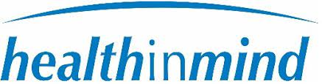**Health in Mind**. We all go through low points at times in our lives and it is not unusual to experience symptoms such as stress, anxiety and depression. Health in Mind is the free NHS Talking Therapies Service for anyone in East Sussex experiencing these kinds of emotional or psychological difficulties. 0300 0030 130 or visit [www.healthinmind.org](http://www.healthinmind.org)

Pregnancy. Just found out you are pregnant? Book to make a contact visit with the Midwife [www.esht.nhs.uk/maternity/referral](http://www.esht.nhs.uk/maternity/referral)

East Sussex Sexual Health. Information and advice on contraception, pregnancy, sexually transmitted infections and cervical screening. Call 0808 1681 282

Adult Social Care Find services to help you live safely at home. Support with carers, confidence, home care, meals on wheels, fall alarms and key safes, equipment and home adaptations. 0345 6080191 8 am – 8 pm 7 days a week.

**NHS Health checks.** Check the criteria below. If you are eligible you can book your own appointment at

[https://outlook.office365.com/owa/calendar/OneYouEastSussexNHSHealthCheckwithFerryRoadSurgery@kick-it.org.uk/bookings/](https://gbr01.safelinks.protection.outlook.com/?url=https%3A%2F%2Foutlook.office365.com%2Fowa%2Fcalendar%2FOneYouEastSussexNHSHealthCheckwithFerryRoadSurgery%40kick-it.org.uk%2Fbookings%2F&data=05%7C01%7Clyn.giles%40nhs.net%7C11d493ec28c8458ed9ce08db9e53c4ae%7C37c354b285b047f5b22207b48d774ee3%7C0%7C0%7C638277854871296327%7CUnknown%7CTWFpbGZsb3d8eyJWIjoiMC4wLjAwMDAiLCJQIjoiV2luMzIiLCJBTiI6Ik1haWwiLCJXVCI6Mn0%3D%7C3000%7C%7C%7C&sdata=rW5zifRKMjnItj5FLTUCF3vNAelJ5J5ija9upXHYCr4%3D&reserved=0)

Please see the eligibility for the NHS Health Check, you will only be eligible for a NHS Health Check if;

•            Aged 40-74?

•            Not have been diagnosed with heart disease, stroke, diabetes, kidney disease, high cholesterol or

high blood pressure.

•            Not be taking medication for blood pressure, cholesterol and diabetes.

•            Have not had an NHS Health Check in the last 5 years.

_____________________________________________________________________________________

.